/

**Trig 2020 – Notes Day #5**

Oftentimes we are asked in trigonometry for an “**exact value**.” At these times, we are ignoring the calculator and looking for more specific values (often they are fractions). But where do these values come from? We get a little help from the special right triangles we used earlier.

Recall the two triangles: 30 – 60 – 90 and the 45 – 45 – 90. Both are right triangles, with specific values across from the angles. Now, how do these help us with our trigonometric functions? We’ll create a table that utilizes these sides and their relationships.

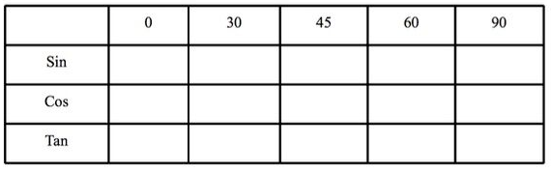

1

$$\frac{\sqrt{3}}{2}$$

$$\frac{\sqrt{2}}{2}$$

$$\frac{\sqrt{1}}{2}$$

0

1

$$\frac{\sqrt{3}}{2}$$

$$\frac{\sqrt{1}}{2}$$

$$\frac{\sqrt{2}}{2}$$

0

$$\sqrt{3}$$

$$\frac{\sqrt{3}}{3}$$

0

Undefined

1

A couple of things to note about the chart. Notice that Sin and Cos are opposite…Sin goes up, Cos goes down. They use the same values, but in reverse. And they are never larger than 1. The most important line is that of **Sin**…it drives the entire table! Know that one, and you’re good! I say that because Cos is just Sin in reverse, and Tan is Sin/Cos…so the Tan values are derived from dividing the Sin value by the Cos value.

Notice that the Tan of 90 is Undefined. This is because dividing by zero leads to undefined values. If and when you get to the graphs of the Trig functions, you’ll see how this undefined value is shown.

**Side Note**: I realize that $\sqrt{1}=1$, but to make all the fractions in the table consistent, I added the radical sign. You won’t see that in every rendition of this table, but I find it helps for memorizing purposes. (Hint, Hint!)

So, how do we use this along with everything else we learned? Let me give you some examples.

**Example 11** What is the Sin of 135 $°$? If we entered this into a calculator, we would get a long, decimal answer. Our chart above, however, can lead us to an exact value answer, but we need to do some thinking.

First: Note that 135 is in the 2nd quadrant, and therefore Sin is still positive (Positivity Chart from last lesson).

Second: We want to use a reference angle, so we subtract 180 – 135 = 45. So my reference angle is 45.

Third: Go to the exact value table above and find Sin 45.

$$\frac{\sqrt{2}}{2}$$

Answer:

A lot goes into this seemingly simple question. Let’s try another.

**Example 12** Find the Cos of 210 $°$.

So, 210 is in Quad 3, where Cos is negative. My reference angle is 30 $°$. In my table, Cos of 30 = $\frac{\sqrt{3}}{2}$.

Therefore, Cos 210 = $-\frac{\sqrt{3}}{2}$. (The negative is there since we’re in Quad 3.)

Homework #5: Try and solve the problems below using all that we’ve learned beforehand, and the exact value table.

1) Sin 225 = 2) Tan 135 = -1

3) Cos 300 = 4) Sin 120 =

5) Cos -120 = 6) Tan 315 = -1

7) Sin 330 = 8) Cos 210 $°$ = $\frac{\sqrt{3}}{2}$